# **Laboratory practice No. 2: Sorting algorithms**

|  |  |
| --- | --- |
| **Sebastian Herrera Beleño**  Universidad Eafit  Medellín, Colombia  Sherrerab1@eafit.edu.co | **Jairo Miguel Marulanda Giraldo**  Universidad Eafit  Medellín, Colombia  jmmarulang@eafit.edu.co |

**3) Practice for final project defense presentation**

**3.1**

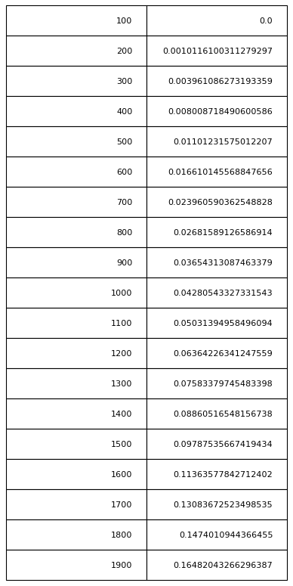

**Insertion Sort**

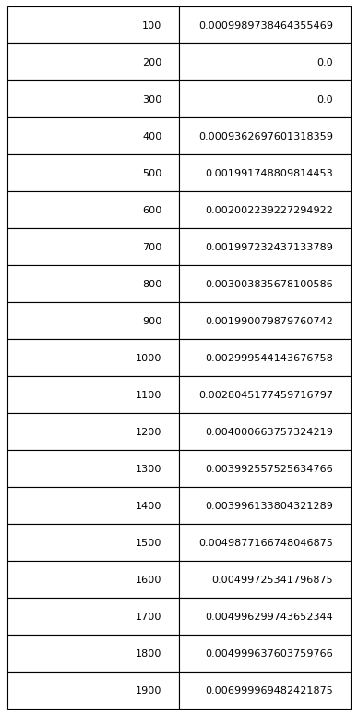

**Merge Sort**

**3.2**

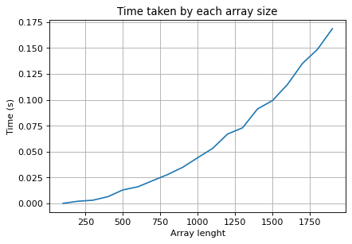

**Insertion Sort**

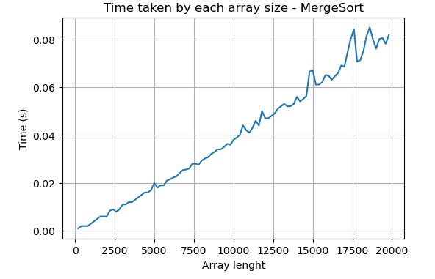

**Merge Sort**

**3.3**

This problem requires an algorithm that prioritizes time over memory, since images must be rendered quickly and efficiently, for otherwise the players experienced and gameplay may be damaged. Therefore, if we consider the enormous quantity of data that must be processed, and how quickly the time complexity of insertion sort increases, then we can conclude that other methods may give better results. Suh as merge sort, which has a much slower time complexity growth.

**3.4**

The logarithm appears in the merge sort complexity function. The why of this can be approached from several perspectives. The simplest, most immediate one is that the logarithm appears from the solution of the recursive equation used inside the algorithm.

Another, more analytical perspective goes as follows. Each time the function is called recursively, the length of the array, call it n, is divided by two, until the result equals one. This implies that the third recursive call of the method will divide n by 2^3, the fourth by 2^4, and so on. Let l be the total number of recursive levels needed to be called such that the length of the array received equals 1.

This implies:

n/(2^l) = 1

n = 2^l

l = log_2(n)

We can now estimate that it takes a complexity of n/2^a, with a being an integer, for each recursive call to end. Additionally, we know that a n/2^a its called on 2^a occasions, since each half of the array then goes on its own separate path until reaching length one. Then the total complexity of all calls for n/2^a arrays equals n. This applies for all array sizes.

Therefore, the total complexity of the algorithm is approximately the number of recursive levels required multiplied by n.

That is to say:

T(n) = l*n = n*log_2(n)

Note, this is an approximation made by analyzing the code, that ignores the exact number of operations made in every step yet helps to understand the formulation of the problem.

**3.5**

Since insertion sort complexity grows so quickly, we need the data set to be small. If this is not possible, we may also note that, unlike merge sort, insertion sort skips the positions that are already organized, so it may be faster if the data set is not too disorganized.

**3.6**

Let us now analyze in more depth the inner workings of the maxSpan algorithm.

We will say that the span of two equla numbers in an array is the number of elements between the two inclusive.

The maxSpan algorithm calculates the longest span inside a given array.

To do this it picks a position of the array to compare, it then iterates from the very last position of the array until it reaches the beginning of it. If any of the values evaluated in this iteration equals the chosen compared value, the distance between the two is compared with any other distance previously found and, if it happens to be larger, the value is saved, replaces the previous as the maximum distance and the iteration cycle is broken. The algorithm then picks another position to compare and repeats the process again, until it reaches the end of the array.

Finally, it returns the maximum distance found.

**3.7**

Let us now calculate the complexity of the suggested exercises.

3.7.1 exercise countEvens:

Let T(n) be the complexity function of the algorithm with n being the length of the array.

We get for the worst case:

T(n) = c0 + c1 + n*c2 + n*c3 + n*c4 + c5, with ci constant.

Then:

T(n) = O(n)

3.7.2 exercise bigDiff:

Let T(n) be the complexity function of the algorithm with n being the length of the array.

We get for the worst case:

T(n) = c0 + c1 + c2 + (n-1)*c3 + (n-1)*c4 + (n-1)*c5 + c8, with ci constant.

Then:

T(n) = O(n)

3.7.3 exercise enteredAverage:

Let T(n) be the complexity function of the algorithm with n being the length of the array.

We get for the worst case:

T(n) = c0 + c1 + c2 + c3 + (n-1)*c4 + (n-1)*c5 + (n-1)*c6 + (n-1)*c9 + c10, with ci constant.

Then:

T(n) = O(n)

3.7.4 exercise sum13:

Let T(n) be the complexity function of the algorithm with n being the length of the array.

We get for the worst case:

T(n) = c0 + c1 + n*c2 + n*c3 + n*c4 + n*c5, with ci constant.

Then:

T(n) = O(n)

3.7.5 exercise sum13:

Let T(n) be the complexity function of the algorithm with n being the length of the array.

We get for the worst case:

T(n) = c0 + c1 + n*c2 + n*c3 + n*c4 + n*c5 + n*c6 +c7 +c8, with ci constant.

Then:

T(n) = O(n)

3.7.6 exercise maxSpan:

Let T(n) be the complexity function of the algorithm with n being the length of the array.

We get for the worst case:

T(n) = c0 + c1 + c2 + n*c3 + n*n*c4 + n*n*c8 + n*n*c9 + n*c10 + c11, with ci constant.

Then:

T(n) = O(n**2)

3.7.7 exercise fix34:

Let T(n) be the complexity function of the algorithm with n being the length of the array.

We get for the worst case:

T(n) = c0 + c1 + n*c2 + n*c3 + n*n*c4 + n*n*c5 + c10, with ci constant.

Then:

T(n) = O(n**2)

3.7.8 exercise fix45:

Let T(n) be the complexity function of the algorithm with n being the length of the array.

We get for the worst case:

T(n) = c0 + c1 + n*c2 + n*c3 + n*n*c4 + n*n*c5 + c10, with ci constant.

Then:

T(n) = O(n**2)

3.7.9 exercise canBalance:

Let T(n) be the complexity function of the algorithm with n being the length of the array.

We get for the worst case:

T(n) = c0 + c1 + n*c2 + n*c3 + c4 + c6 + c7 + n*c8 + c*c9 + c*c10 + c12, with ci constant.

Then:

T(n) = O(n)

3.7.10 exercise linearIn:

Let T(n) be the complexity function of the algorithm with n being the length of the outer array.

We get for the worst case:

T(n) = c0 + c1 + n*c2 + c3 + n*c4 + n*c5 + n*c6 + n*c11 + c12, with ci constant.

Then:

T(n) = O(n)

Note, we assume that either inner has the same length of outer or the element matches for inner are located in the very last positions of outer, such that the whole array outer must be evaluated.

3.7.11 insertion sort:

Let T(n) be the complexity function of the algorithm with n being the length of the array.

We get for the worst case:

T(n) = (n-1)*c1 + (n-1)*c2 + ((n*(n-1))*2)*c4 + ((n*(n-1))*2)*c5 + ((n*(n-1))*2)*c6 + n*c7, with ci constant.

Then:

T(n) = O(n**2)

3.7.12 merge sort:

Let T(n) be the complexity function of the algorithm with n being the length of the array.

We get for the worst case:

T(n) = c1 + c2 + c3 + c4 + T(n/2) + c5 + T(n/2) + c6 + c7 + (n/2)*c8 + (n/2)*c9 + (n/2)*c10 +

(n/2)*c11 + (n/2)*c12 + (n/2)*c14 + n*c15 + n*c16 + n*c17 + n*c18 + n*c19 + n*c20 + n*c21 + n*c22

with ci constant.

Which we can simplify as

T(n) = 2T(n/2) + O(n) = (c*n/2) + nlog_2(n), with c constant.

Then

T(n) = O(nlog_2(n)).

**3.6**

Let us analyze in more dept the inner workings of the maxSpan algorithm.

***4)* Practice for midterms**

* 1. It would take approximately 10 seconds.
  2. d
  3. a
  4. The time *complexity equals O(m*n). The matrix ocuppies aproximately 4*m*n bytes, so the space complexity equals O(m*n)*
  5. a
  6. b